**PROJECT**

**1st Increment Report**

**on**

**“APP REVIEWER”**

**By**

**Vinil Kumar Kamigari**

**Sumanth Koushik Kalli**

**Alekhya Boyapati**

**Importing Existing Services:**

The existing services used in this increment are HTML language, Javascript and cascading style sheets (CSS) for implementing the user interface. In future we are going to use the description and ratings of apps from this site (<https://play.google.com/store/apps?hl=en>). We have already contacted the Google Play Store team to get an API for using their existing app details along with their reviews.

**Detail Design of Services:**

In this design of mobile interface we created the required home page for the selection of different categories of apps, the user wants to view. Basically, whenever the user presses on particular category all the apps related to that category will be displayed. We have just created the category box and are going to build the app selection for viewing the reviews in upcoming increments.

**Sequence Diagram:**

The below diagram shows the sequence diagram of our application.

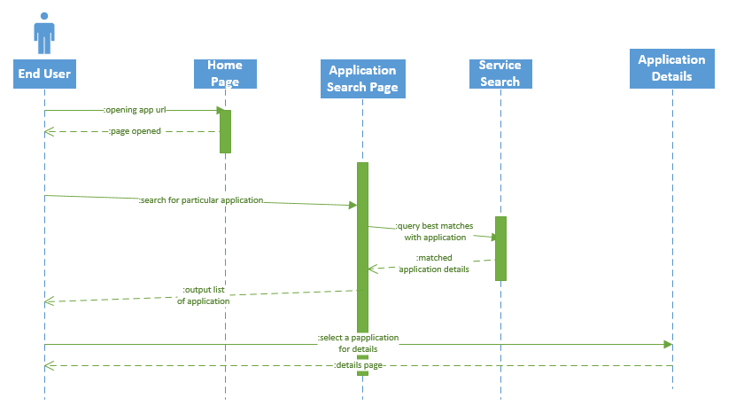

**Screen shot of our Interface:**

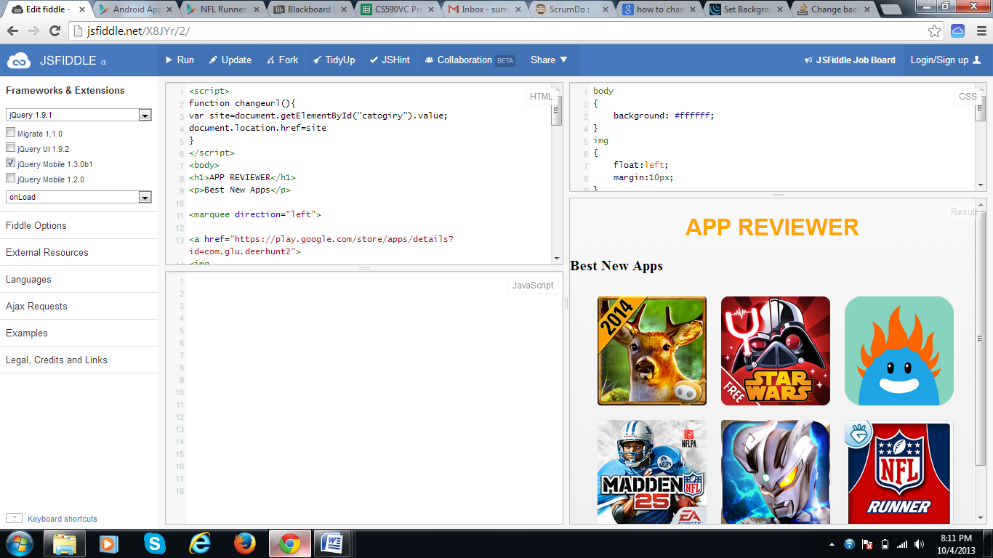

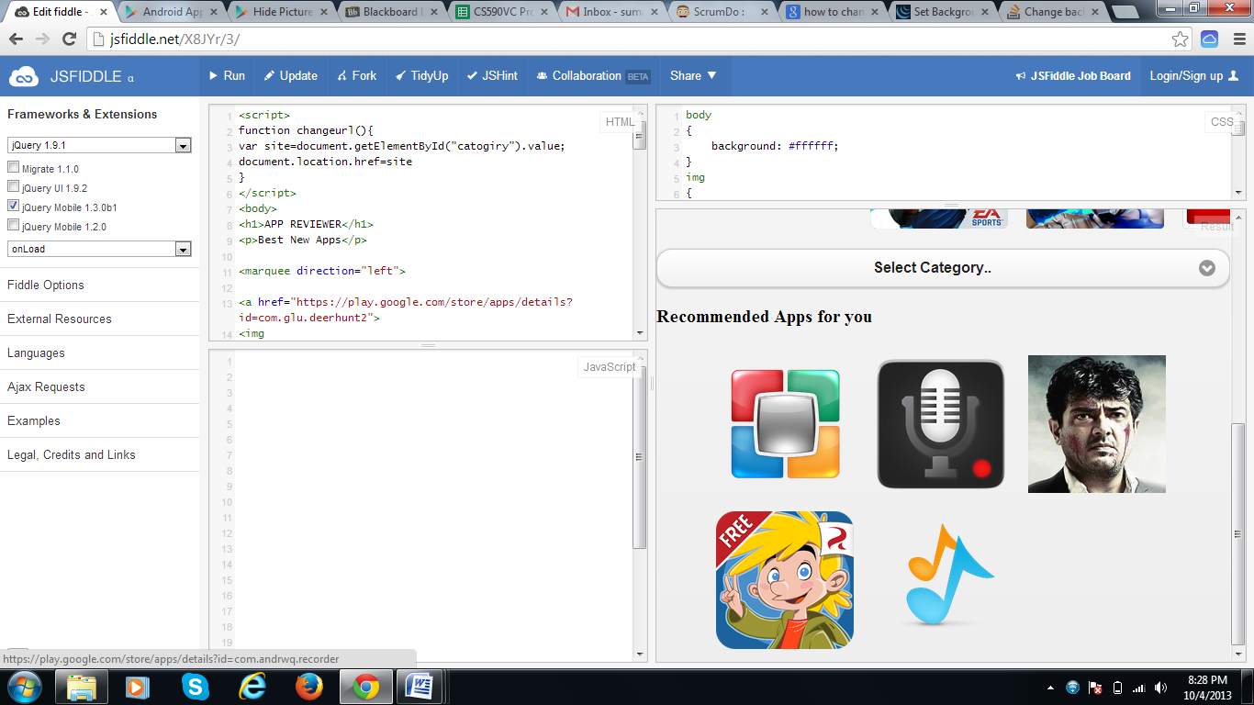

**Implementation**

**Implementation of services:** We created home screen for our project and also the selection of category for sorting the apps and to provide user with easy access. However we are going to use Hadoop for analyzing number of users downloaded a particular app, their reviews about the apps in the further increments.

**Generate your datasets:** We have created the different categories that are available in apps and are going to create datasets for each category. So, whenever the user presses the app belonging to the category then the details about the app are being analyzed using Hadoop and then displayed to the user.

**Implementation of user interface (Mobile Apps):** Here we implemented the user interface using the HTML language and Cascading style sheets. The initial home screen is developed in this project for this increment. Further modules will be added in next increments.

**Report:** In our project “APP REVIEWER” we have developed the front end using HTML, JavaScript and CSS as part of First increment.

We added features which include “New Releases”, which allows the user to get the list of recently released apps and then we also added a feature which allows the user to select a particular category in selecting an application from the huge pool set of Apps.

We also included “Recommended apps for you”, which recommends user with apps.

We have used the Google’s Play store to get the information about Apps and also redirected the apps to that site if user requests information for time being.

We have requested the Google Play store team for an API where in we can use the Information about Apps directly without redirecting it to their site and are looking forward for their response.

**Step 1:** Here the Best New Apps can be seen and when the user just selects any of the app he is interested in then it redirects to the Google Play Store and he can download and read more number of reviews before downloading the app.



**Step 2:** Here is the image which shows the recommended apps for a particular user based on his interests.



Step 3: The HTML source code used in making this application is shown below.

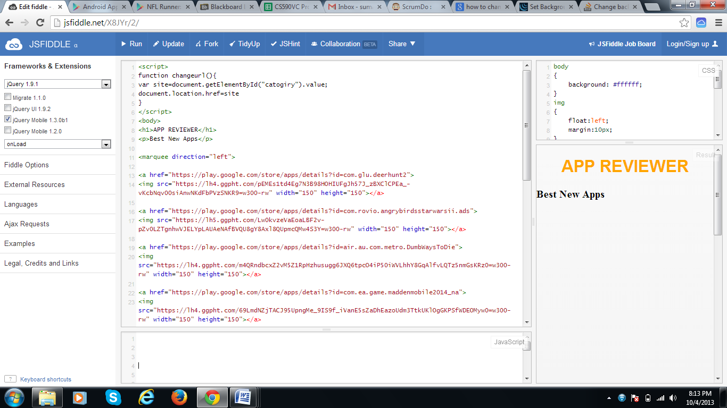

Step 4: The CSS code used in making of this application is shown below.

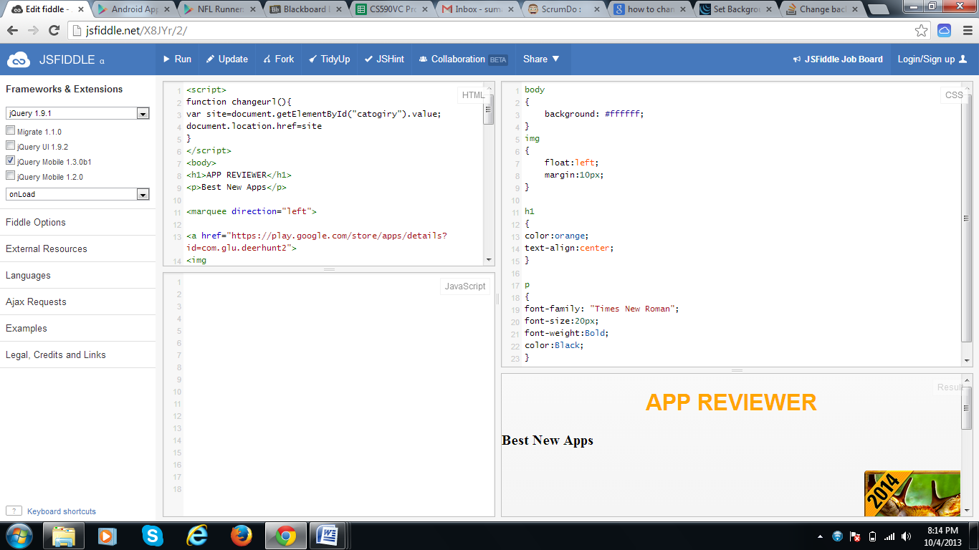

**Implementation Status Report**

**Work Completed:**

* **Description:** In the first increment, we completed the Front end design using HTML, JavaScript and CSS and also collected data on various categories of applications. In Front end application we have included three features

1. Best New Apps
2. Select Category[of apps]
3. Recommended apps for you

“Best New Apps” provides the user with latest apps from the Google’s play store and “Recommended apps for you” shows the best recommended apps according to the user’s interest. “Select Category” allows the user to select a wide range of categories in apps ranging from Books to Weather.

* **Responsibility:**

**Best New Apps:** The Best New Apps is done by Sumanth Koushik Kalli and the apps are

provided with hyperlink to get into more information about the app.

**Recommended apps for you:** The Recommended apps for you is done by Sumanth

Koushik Kalli and the apps are provided with hyperlink

to get into more information about the app.

**Select Category:** The Select category has been done by Alekhya Boyapati and the

various categories are added in the Drop box to facilitate the user in

selecting apps.

**Collection of Static Data:** Static Data about nearly 200 apps are collected from the Play

store for testing byAlekhya and Sumanth. The data collected

includes App Name, Rating of the app, Reviews of the app.

**Documentation:** Documentation for the 1st increment has been prepared by Vinil Kumar,

Sumanth Koushik Kalli and Alekhya Boyapati.

* **Time Taken:** We spent around 90 hours each for learning how to get data, learning Hadoop and making the User Interface.
* **Contributions:**

**Sumanth:** Studying sources of Data, contacting organizations for getting Data, Part of HTML coding, providing styling using CSS and documentation.(35%)

**Alekhya:** Studying sources of Data, Part of HTML coding for User Interface and documentation. (35%)

**Vinil:** Studying sources of Data and documentation (30%)

**Work to be completed:**

* **Description:** In the future increments, we look forward to complete the select category option and work on with “Select by Interest” and mainly getting an API to access the data from Google Play store.

We are working on developing a program to rate the apps based on the information we get from each application and then show the user with the results and allow him to take an intelligent decision in choosing which app he has to download for a particular category and interest.

* **Responsibility:**

Bringing up a program for analzing the obtained data will be shared by three of us equally. Sumanth mainly is involved in getting an API from Google Team. Select by Interest is being looked in by Alekhya

* **Time Taken:** We estimate that we require around 120 hours each for an increment.

**Issues/Concerns:**

The major concern in this increment was getting Data. We have requested Google and another reviewer website for providing data and the latter has agreed to share data with us. But, since we need large amount of data we are waiting for Google to respond to our request.

**Deployment:**

Scrum Do Link: <https://www.scrumdo.com/uploader/project/project-162/>

Github Link: <https://github.com/sumanth2109/Increment-1>